**Instruction to update Radtel RT-950 or RT-950 PRO**

1. Click the update tool (rt-950 and rt-950 pro use same upgrade tool)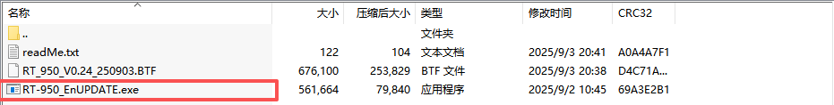
2. Load the firmware file RT_950.BTF and select COM port 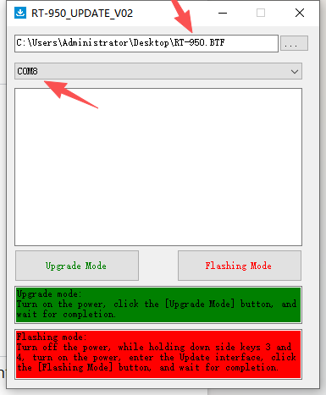
3. Turn ON the power (don’t need to press any combine keys)

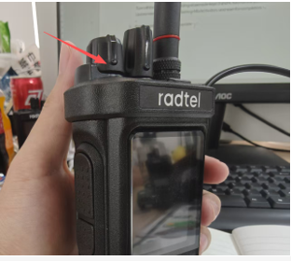

4.The screen will show a update logo and press Upgrade Mode to upgrade firmware

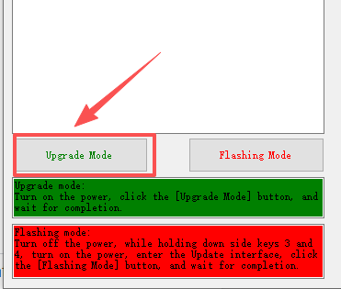

After finish, it shows 100% and radio power on again

The update have been completed!

**How to fix it if the radio become brick after upgrade ??? Don’t worry, please follow this steps:**

1.Remove the battery and wait for 10 seconds

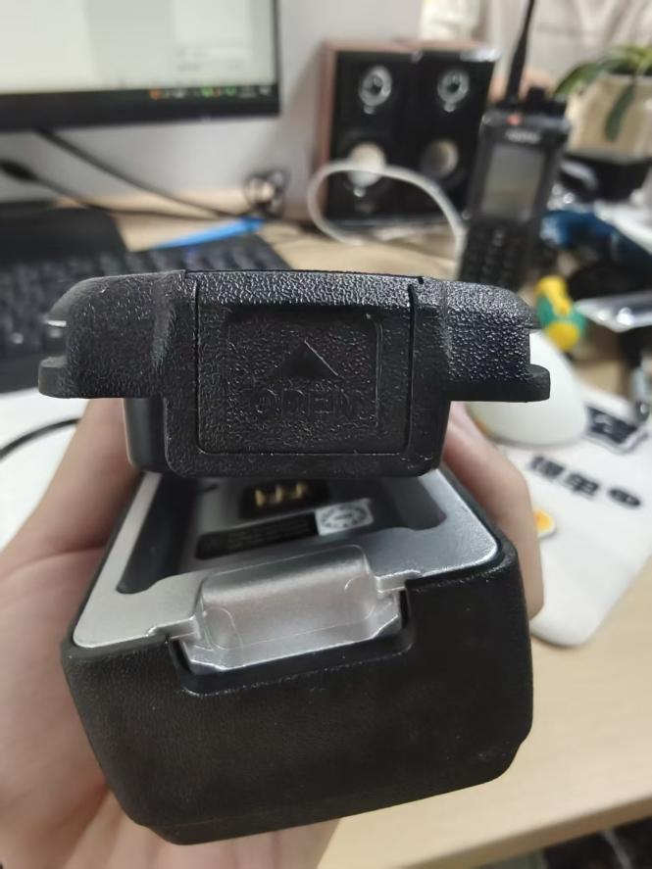

1. Turn off the power
2. holding down side keys 3 and 4, while turn on the power enter the Update interface

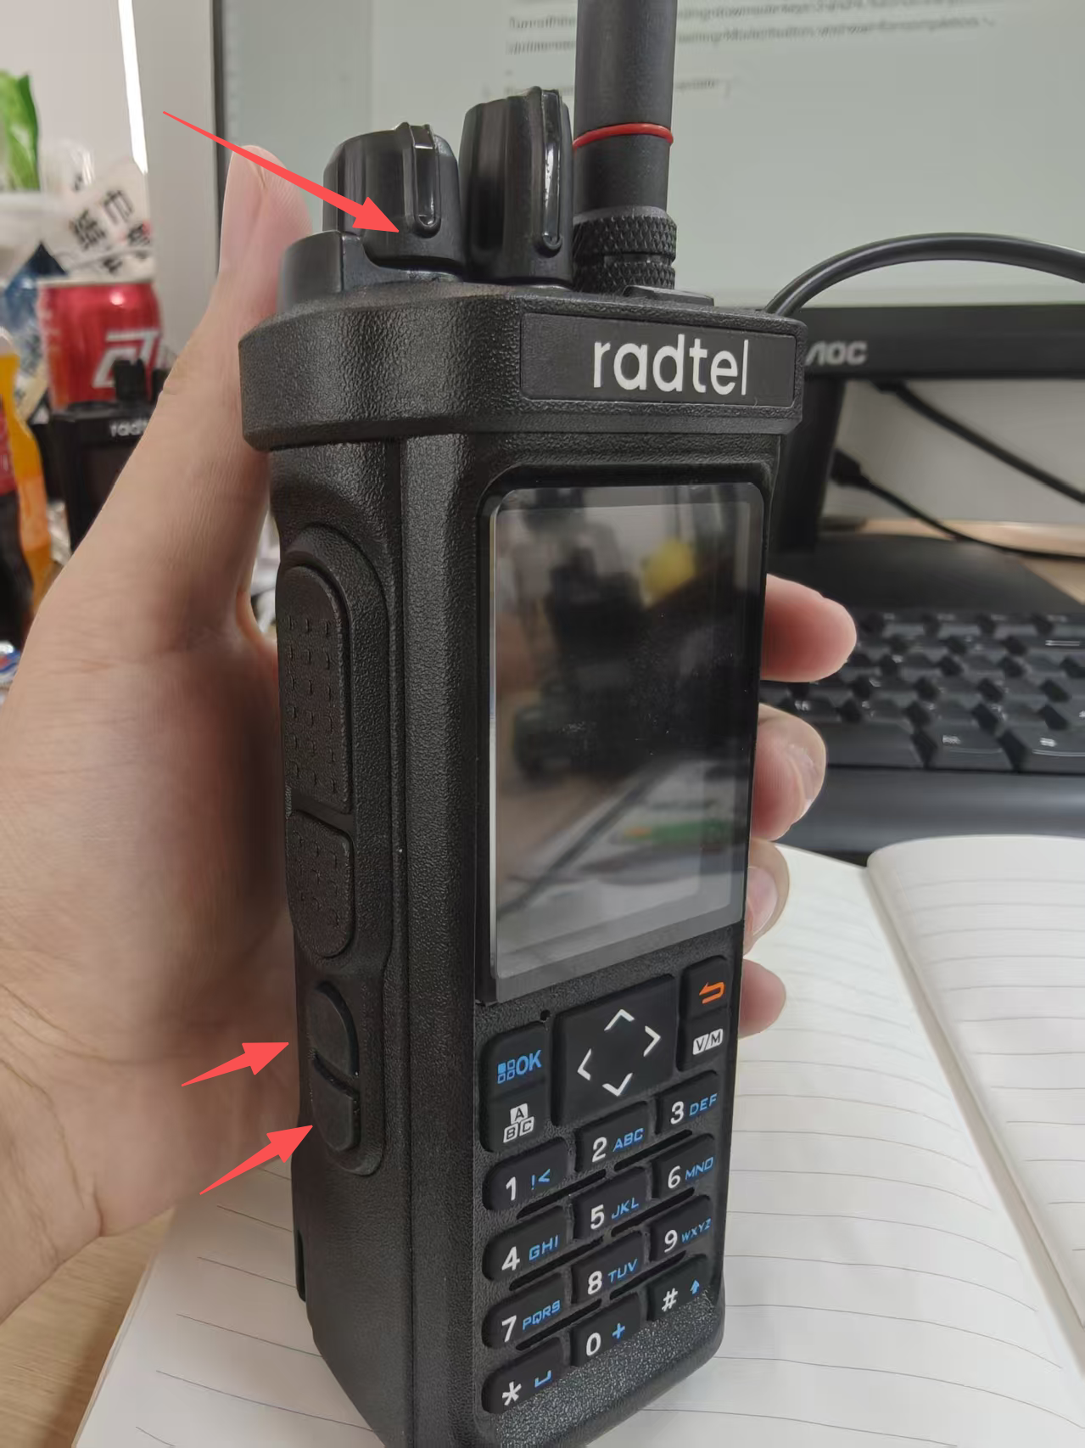

1. click the [Flashing Mode] button, and wait for 100% completion

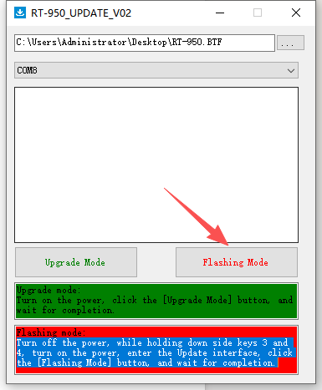

After finish, it shows 100% and radio power on again